Robber Barons or Captains of Industry?

Big Business at the

Turn of the 20th Century

**An Inquiry Design Model for Grade 11**

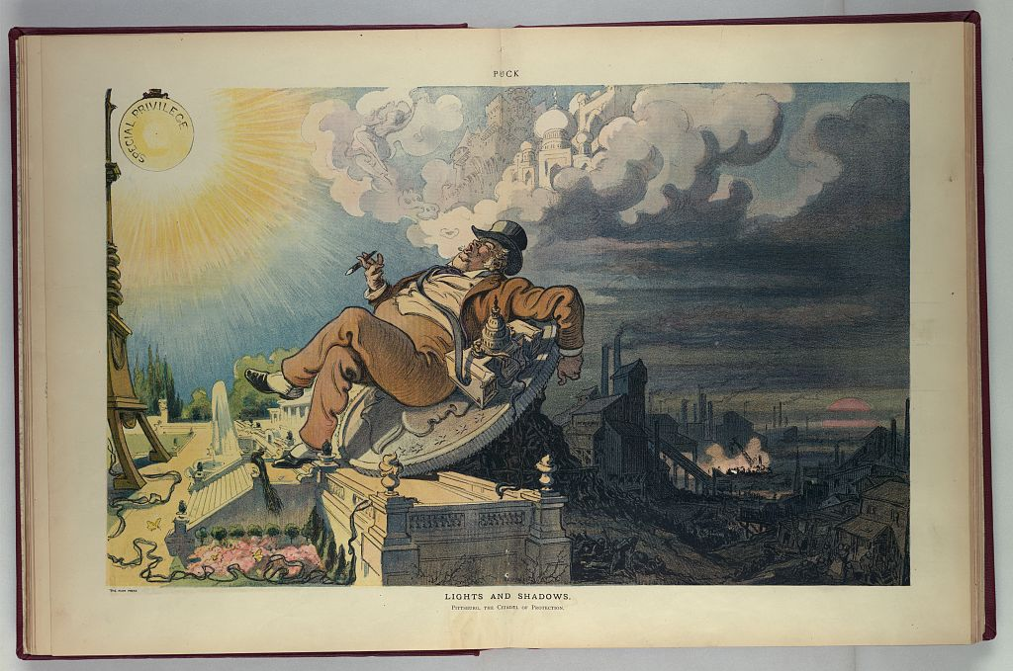

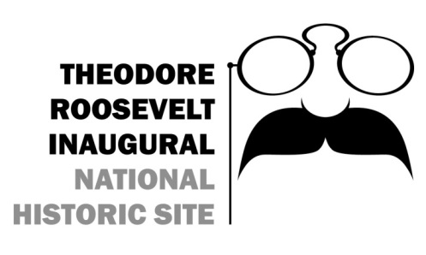

**641 Delaware Avenue, Buffalo, NY 14202 ·** [**www.trsite.org**](http://www.trsite.org) **· 716-884-0095**

**By Buffalo City School District teachers Renee Kasianowicz, Adrianne Lampham, Sara Holt, Aaron Shia & Kristin Manhart**

Robber Barons or Captains of Industry?

Big Business at the

Turn of the 20th Century

**An Inquiry Design Model for Grade 11**

**Compelling Question**

**How did Americans feel about Big Business Leaders?**

**Supporting Questions**

1. **What is the difference between a robber baron and a captain of industry?**
2. **How would you classify J.P Morgan, Andrew Carnegie and J.D. Rockefeller: captains of industry of robber barons?**
3. **Who do you most agree with? Ida M. Tarbell, John D. Rockefeller or Mr. Chief Justice White about the Standard Oil Company.**

|  |  |  |  |  |
| --- | --- | --- | --- | --- |
| Inquiry Design Model (IDM) Blueprint™ | | | | |
| **Compelling Question** | How did Americans feel about Big Business Leaders? | | | |
| Standards and Practices | 11.5a New technologies and economic models created rapid industrial growth and transformed the United States.  Students will examine the growth of industries under the leadership of businessmen such as John D. Rockefeller, Andrew Carnegie, J.P. Morgan, and Henry Ford and analyze their business practices and organizational structures. | | | |
| Staging the Question | During the American Industrial Revolution, were there more Captains of Industry or Robber Barons? | | | |
| **Supporting**  **Question 1** | | | **Supporting**  **Question 2** | **Supporting**  **Question 3** |
| **What is the difference between a robber baron and a captain of industry?** | | | **How would you classify J.P Morgan, Andrew Carnegie and J.D. Rockefeller: Captains of Industry of Robber Barons?** | **Who do you most agree with?** Ida M. Tarbell, John D. Rockefeller or Mr. Chief Justice White about The Standard Oil Company. |
| **Formative**  **Performance Task** | | | **Formative**  **Performance Task** | **Formative**  **Performance Task** |
| **Students will compare the views of big business men and write a three paragraph response to the supporting question** | | | **After reading about each business leader, fill out the graphic organizer. Then explain your reflection on whether each one was a captain of industry or a robber baron.** | **Students will be assigned 1 of the 3 texts to read. With classmates they will prepare to hold a debate to argue their stance on Big Business: Standard Oil Company.** |
| **Featured Sources** | | | **Featured Sources** | **Featured Sources** |
| Source A: [Comparative Chart](http://senn-academyhs.enschool.org/ourpages/auto/2015/2/12/42488395/Robber_Baron_vs_Captain_of_Industry.pdf)  Appendix A  Source B: [Political Cartoon](https://www.google.com/search?q=robber+barons+or+captains+of+industry+political+cartoons&espv=2&tbm=isch&imgil=kk7cVBRWBeJerM%253A%253BKiacnnPqXT6ZbM%253Bhttps%25253A%25252F%25252Fwww.slideshare.net%25252Fsmalvarado%25252Frobber-baronsor-captainsofindustryppt&source=iu&pf=m&fir=kk7cVBRWBeJerM%253A%252CKiacnnPqXT6ZbM%252C_&usg=__OCaiibv4kvbDoaFolg5fVUU6084%3D&biw=1366&bih=638&ved=0ahUKEwj9lIHczefSAhXk1IMKHYpgB9EQyjcILA&ei=tB3RWP3qEeSpjwSKwZ2IDQ&safe=active&ssui=on#imgrc=VklnjnhgYmAqxM:)  Appendix B  Source C: [**Big Business Video**](http://www.history.com/topics/us-presidents/theodore-roosevelt/videos/theodore-roosevelt-vs-big-industry)  [**http://www.history.com/topics/us-presidents/theodore-roosevelt/videos/theodore-roosevelt-vs-big-industry**](http://www.history.com/topics/us-presidents/theodore-roosevelt/videos/theodore-roosevelt-vs-big-industry) | | | **Source: Reading selection of Morgan, Carnegie and Rockefeller**  Appendix C-E  **Source F: Chart of Business Leaders: Robber Barons or Captains of Industry?**  Appendix F | **“On the Standard Oil Company”**  [**http://nationalhumanitiescenter.org/pds/gilded/power/text2/standardoil.pdf**](http://nationalhumanitiescenter.org/pds/gilded/power/text2/standardoil.pdf) |
| Summative  Performance Task | **Argument** | How did Americans feel about Big Business Leaders?  Construct an argument (e.g., detailed outline, poster, or persuasive essay, power point, prezi) using specific claims and relevant evidence from historical sources. | | |
| **Extension** | Students will email their Congressmen information from their portfolio. | | |
| Taking Informed Action | **UNDERSTAND** Research a company today that you feel could be a Robber Baron.  **ASSESS** Create a portfolio of various options that you would do to be more like a captain of industry.  **ACT** Contact your local assemblymen to meet and discuss your portfolio. | | | |

**Captains of Industry vs. Robber Barons**

|  |  |
| --- | --- |
| **Characteristics of a**  **Captain of Industry** | **Characteristics of a**  **Robber Baron** |
| * **Increases availability of goods by building factories.** | * **Drains the country of its natural resources.** |
| * **Raises productivity.** | * **Corrupts public officials to interpret laws in their favor.** |
| * **Expands markets.** | * **Drives competitors to ruin.** |
| * **Creates more jobs.** | * **Pays poor wages.** |
| * **Funds many of the nation’s public institutions/practices philanthropy (giving generously to charitable causes).** | * **Forces workers to toil under dangerous and unhealthy conditions.** |
| * **Organizes the factors of production efficiently.** | * **Exploits the factors of production.** |

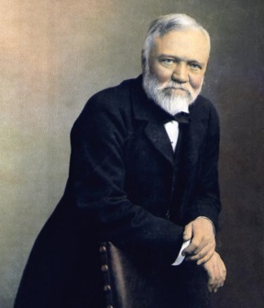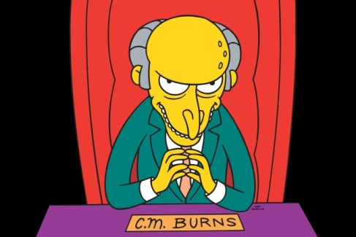

**Andrew Carnegie Mr. Burns**

|  |  |
| --- | --- |
| * **Founded thousands of public libraries.** | * **Tried to cover up the sun to raise energy prices.** |
| * **Founded Carnegie Institute to fund scientific and technological research.** | * **Steals candy from babies.** |
|  | * **Runs a nuclear power plant that pollutes the environment and caused Homer to become sterile.** |
|  | * **Skimps on the tartar sauce in the factory cafeteria.** |

Appendix A

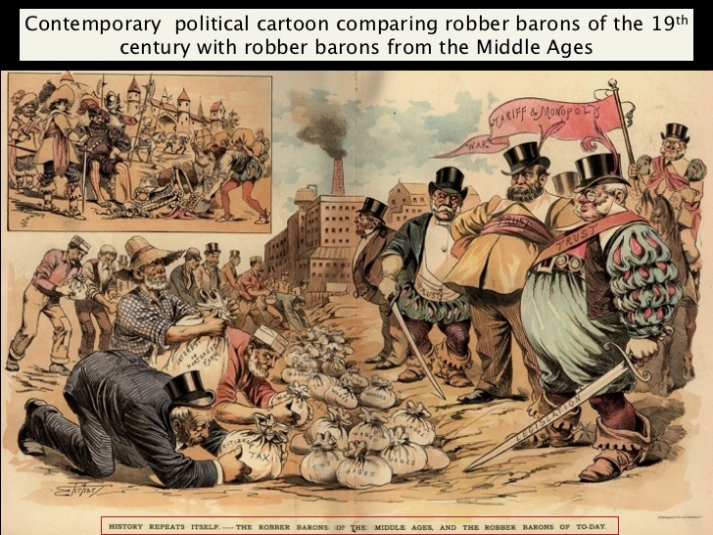

Appendix B

**J.P. Morgan**

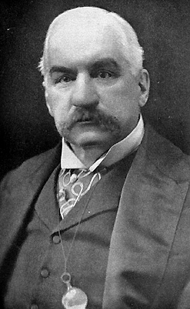John Pierpont Morgan was an [American](http://en.wikipedia.org/wiki/United_States) financier, banker and art collector who dominated [corporate finance](http://en.wikipedia.org/wiki/Corporate_finance) and [industrial consolidation](http://en.wikipedia.org/wiki/Industrial_consolidation) during his time. Morgan was also a philanthropist: he bequeathed (donated after he died) much of his large art collection to the [Metropolitan Museum of Art](http://en.wikipedia.org/wiki/Metropolitan_Museum_of_Art) in [New York City](http://en.wikipedia.org/wiki/New_York_City) and to the [Wadsworth Athenaeum](http://en.wikipedia.org/wiki/Wadsworth_Atheneum) of [Hartford](http://en.wikipedia.org/wiki/Hartford), Connecticut. His son, [J. P. Morgan, Jr.](http://en.wikipedia.org/wiki/J._P._Morgan,_Jr.), made the [Pierpont Morgan Library](http://en.wikipedia.org/wiki/The_Morgan_Library_%26_Museum) a public institution in 1924 as a memorial to his father.

Morgan entered banking in 1857. During the [American Civil War](http://en.wikipedia.org/wiki/American_Civil_War), Morgan was approached to finance the purchase of outdated rifles being sold by the army for $3.50 each. Morgan's partner re-machined them and sold the rifles back to the army for $22 each. While it became a scandal, the military knew it was buying back its own guns and Morgan never even saw the guns, acting only as a lender. Morgan himself, like many wealthy persons, avoided military service by paying $1,000 for a substitute.

After the Civil War, Morgan financed a [railroad](http://en.wikipedia.org/wiki/Railroad) empire. Morgan took over troubled railroads and companies and reorganized them in order to return them to profitability. This process became known as “morganization.” His reputation as a clever banker and financier also helped bring interest from investors to the businesses he took over.

After Congress passed the [Interstate Commerce Act](http://en.wikipedia.org/wiki/Interstate_Commerce_Act) in 1887 (this was created to regulate the rates railroads were charging), Morgan set up conferences in 1889 and 1890 that brought together railroad presidents in order to help the industry follow the new laws and write agreements for the maintenance of "public, reasonable, uniform and stable rates."

In 1895, at the depths of the [Panic of 1893](http://en.wikipedia.org/wiki/Panic_of_1893), the Federal Treasury was nearly out of gold. President [Grover Cleveland](http://en.wikipedia.org/wiki/Grover_Cleveland) arranged for Morgan to create a private syndicate on Wall Street to supply the U.S. Treasury with $65 million in gold, half of it from Europe, to float a bond issue that restored the treasury surplus of $100 million.

Enemies of banking attacked Morgan for the terms of his loan of gold to the [federal government](http://en.wikipedia.org/wiki/Federal_government) in the 1895 crisis, for his financial resolution of the [Panic of 1907](http://en.wikipedia.org/wiki/Panic_of_1907), and for bringing on the financial ills of the [New York, New Haven and Hartford Railroad](http://en.wikipedia.org/wiki/New_York,_New_Haven_and_Hartford_Railroad).

Appendix C

**Andrew Carnegie**

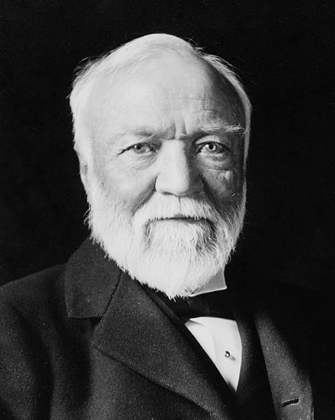Oil was not the only commodity in great demand during the Gilded Age. The nation also needed steel. The railroads needed steel for their rails and cars, the navy needed steel for its new naval fleet, and cities needed steel to build skyscrapers. Every factory in America needed steel for their physical plant and machinery. Andrew Carnegie saw this demand and seized the moment.

Like John Rockefeller, Andrew Carnegie was not born into wealth. When he was 13, his family came to the United States from Scotland and settled in Allegheny, Pennsylvania, a small town near Pittsburgh. His first job was in a cotton mill, where he earned $1.20 per week. His talents were soon recognized and Carnegie found himself promoted to the bookkeeping side of the business. An avid reader, Carnegie spent his Saturdays in the homes of wealthy citizens who were gracious enough to allow him access to their private libraries. After becoming a telegrapher for a short while, he met the head of a railroad company who asked his services as a personal secretary. By the end of the Civil War, Carnegie had stockpiled a small sum of money, which he quickly invested in iron and steel—an industry that benefited from the Bessemer Process, which allowed iron to be converted to steel cheaply and quickly.

Carnegie became an incredibly wealthy businessman because of shrewd business tactics. While Rockefeller often bought other oil companies to eliminate competition—a process known as horizontal integration—Carnegie also used vertical integration, buying up the industries in every step of the steel-making process. Carnegie bought railroad companies and iron mines, believing correctly that if he owned the rails and the mines, he could reduce his costs and produce cheaper steel.

Carnegie was a good judge of talent. His assistant, Henry Clay Frick, helped manage the Carnegie Steel Company on its way to success. Carnegie also wanted productive workers. He wanted them to feel that they had a vested interest in company prosperity so he initiated a profit-sharing plan. All these tactics made the Carnegie Steel Company a multi-million dollar corporation. In 1901, he sold his interests to J.P. Morgan, who paid him $500 million to create U.S. Steel.

Carnegie devoted much of his life to giving back. Before his death he donated more than $350 million dollars to public foundations. Remembering the difficulty of finding suitable books as a youth, he helped build three thousand libraries. He built schools such as Carnegie Mellon University in Pennsylvania, and gave money to build the famous music house Carnegie Hall in New York.

Andrew Carnegie was also dedicated to peace initiatives throughout the world because of his passionate hatred for war. Like Rockefeller, critics labeled him a robber baron who could have used his vast fortunes to increase the wages of his employees. Carnegie believed that such spending was wasteful and temporary, but foundations would last forever. Regardless, he helped build an empire that led the United States to world power status.

Modified from [http://www.ushistory.org/us/36b.asp](http://www.ushistory.org/us/36c.asp) and <http://www.ushistory.org/us/36c.asp>

Appendix D

**John D. Rockefeller**

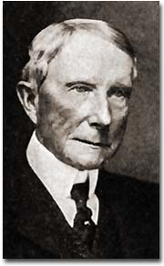 He was America's first billionaire. Overcoming humble beginnings, Rockefeller had the vision and the drive to become the richest person in America. At the turn of the century, when the average worker earned $8 to $10 per week, Rockefeller was worth millions. What was his secret? Is he to be placed on a pedestal for others as a “Captain of Industry?” Or should he be demonized as a "robber baron." Arobber baron, by definition, was an American capitalist at the turn of the 20th century who enriched himself upon the sweat of others, exploited natural resources, or possessed unfair government influence. Whatever conclusions can be drawn, Rockefeller's impact on the American economy demands recognition.

Rockefeller was born in 1839 in Moravia, a small town in western New York. His father practiced herbal medicine, professing to cure patients with remedies he had created from plants in the area. John's mother instilled a devout Baptist faith in the boy, a belief system he took to his grave. After being graduated from high school in 1855, the family sent him to a Cleveland business school.

Young John Rockefeller entered the workforce on the bottom rung of the ladder as a clerk in a Cleveland shipping firm. Always thrifty, he saved enough money to start his own business in produce sales. When the Civil War came, the demand for his goods increased dramatically, and Rockefeller found himself amassing a small fortune. When Edwin Drake discovered oil in 1859 in Titusville, Pennsylvania, Rockefeller saw the future. He slowly sold off his other interests and became convinced that refining oil would bring him great wealth.

Rockefeller introduced techniques that totally reshaped the oil industry. In the mid-19th century, the chief demand was for kerosene. In the refining process, there are many by-products when crude (raw) oil is converted to kerosene. What others saw as waste, Rockefeller saw as gold. He sold one byproduct, paraffin, to candle-makers and another byproduct, petroleum jelly, to medical supply companies. He even sold off other "waste" as paving materials for roads. He shipped so many goods that railroad companies drooled over the prospect of getting his business. Rockefeller demanded rebates, or discounted rates, from the railroads. He used all these methods to reduce the price of oil to his consumers. His profits soared and his competitors were crushed one by one.

Rockefeller forced smaller companies to surrender their stock to his control, an arrangement known as a trust. A trust is a combination of firms formed by legal agreement. Trusts often reduce fair business competition. As a result of Rockefeller's shrewd business practices, his large corporation, the Standard Oil Company, became the largest business in the land. As the new century dawned, Rockefeller's investments grew rapidly. With the rise of the automobile, gasoline replaced kerosene as the number one oil product. Rockefeller was the first billionaire. Critics charged that his labor practices were unfair. Employees pointed out that he could have paid his workers a fairer wage and settled for being a half-billionaire.

Before his death in 1937, Rockefeller gave away nearly half of his fortune. Churches, medical foundations, universities, and centers for the arts received hefty sums of oil money. Whether he was driven by good will, conscience, or his devout faith in God is unknown. Regardless, he became a hero to many enterprising Americans.

Modified from [http://www.ushistory.org/us/36b.asp](http://www.ushistory.org/us/36c.asp) and <http://www.ushistory.org/us/36c.asp>

Appendix E

**Business Leaders: Robber Barons or Captains of Industry?**

|  |  |  |  |
| --- | --- | --- | --- |
| **Business Leader** | **Captain of Industry** | **Robber baron** | **Reflection** |
| Image result for andrew carnegie**Andrew Carnegie** |  |  |  |
| Image result for john d. rockefeller  **John D. Rockefeller** |  |  |  |
| Image result for j.p. morgan  **J.P. Morgan** |  |  |  |

Appendix F