The Pan-American Exposition,
Race, and Social Inequalities

An Inquiry Design Model for Grade 4

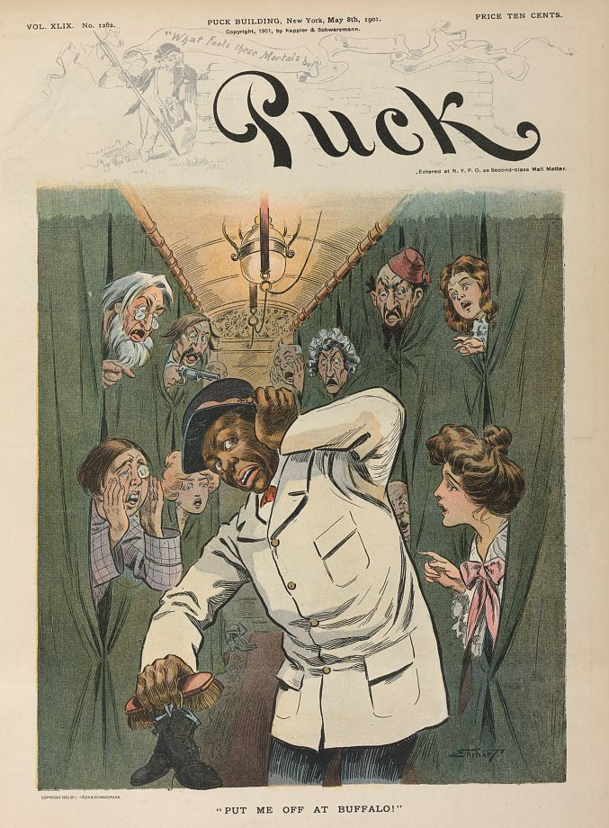
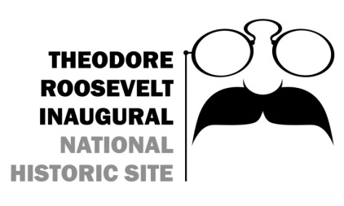
641 Delaware Avenue, Buffalo, NY 14202 · www.trsite.org · 716-884-0095

By Buffalo City School District teachers Jennifer Reiss, Gregory Schiltz, Jennifer Previty, Charlene Palladino and Amy Blake
The Pan-American Exposition,
Race, and Social Inequalities

An Inquiry Design Model for Grade 4

Compelling Question
What can the Pan American Exposition of 1901 tell us about race and social inequalities in America at the turn of the 20th century?

Supporting Questions
- What was Buffalo’s ethnic and racial makeup in 1901? Why? Was the city segregated? Why? How has that changed over the last 116 years?

- Who were the Americans that visited the Pan American Exposition? What was their socioeconomic and ethnic makeup? Captains of Industry or Robber Barons?

- Who were the Americans that comprised the exhibits of the Pan American Exposition? How were they portrayed? How would that be different today?

Inquiry Design Model (IDM) Blueprint™
Compelling Question | What can the Pan American Exposition of 1901 tell us about race and social inequalities in America at the turn of the 20th century?
Standards and Practices | Call for Change 4.4 & 4.5  4.4c GOVERNMENT AND CITIZENS Government in New York State is organized into counties, cities, towns, and villages. Students will identify the county in which they live, noting where their city, town or village is within that county. (Standards: 1, 5; Themes: GOV, CIV)  4.5 IN SEARCH OF FREEDOM AND A CALL FOR CHANGE: Different groups of people did not have equal rights and freedoms. People worked to bring about change. (Standards: 1, 5; Themes: ID, TCC, SOC, CIV)
Staging the Question | Students will discuss, in small groups, the different socio-economic and ethnic backgrounds of the people currently living in in the United States. How has that evolved over time? Has much changed since the inception of our country? Do we still have some of the same problems? Why?
Supporting  Question 1 |  |  | Supporting  Question 2 | Supporting  Question 3
What was Buffalo’s ethnic and racial makeup in 1901? Why? Was the city segregated? Why? How has that changed over the last 116 years? |  |  | Who were the Americans that visited the Pan American Exposition? What was their socioeconomic and ethnic makeup? Captains of Industry or Robber Barons? | Who were the Americans that comprised the exhibits of the Pan American Exposition? How were they portrayed? How would that be different today?
Formative  Performance Task |  |  | Formative  Performance Task | Formative  Performance Task
Students will highlight their neighborhood (street) on a map from 1901 and a map from today. How has it changed over the past 116 years? For the better or worse? Why? What do you think your neighborhood will look like in 50 years? Explain. Students who live in the same section of town can work together. |  |  | Utilizing at least 9 Unit vocabulary words, write three paragraphs describing the typical experience while visiting the Pan American Expo. Individual task. | Students work in groups to design and draw new exhibits that feature the same ethnic groups today. What information would be highlighted in a current museum display?
Featured Sources |  |  | Featured Sources | Featured Sources
Doing the Pan website http://panam1901.org/index.html  Immigrant Communities of Buffalo and the Pan-American Exposition  http://library.buffalo.edu/pan-am/exposition/immigrants/  All Roads Will Led To Buffalo In September https://www.loc.gov/item/2004625832/  Historical Maps of Buffalo, Erie County, and Western New York http://www.buffaloresearch.com/maps.html  Buffalo, NY CensusViewer http://censusviewer.com/city/NY/Buffalo  Racial Dot Map http://demographics.coopercenter.org/racial-dot-map/  Buffalo, NY Ethnic Maps  https://nyheritage.org/  Search for: Buffalo Municipal Housing Authority Report maps  Buffalo Architecture Map http://buffalohistory.org/Learn/Research-Library/Digitized-Materials.aspx  City of Buffalo Neighborhood map https://library.buffalo.edu/maps/buffalo-wnymaps/buffalo-neighborhoods.html  Buffalo City Map https://digitalcollections.nypl.org/items/510d47e3-1b4a-a3d9-e040-e00a18064a99 |  |  | Library of Congress website  https://www.loc.gov  Doing the Pan website  http://panam1901.org/index.html  Immigrant Communities of Buffalo and the Pan-American Exposition  http://library.buffalo.edu/pan-am/exposition/immigrants/  http://www.buffalohistoryworks.com  The Pan-American Exposition  http://www.trsite.org/learn/the-pan-american-expo  ExpoMuseum  http://www.expomuseum.com/1901/  A Trip Around the Pan-American Exposition -films  https://www.loc.gov/item/00694338 | Pan-American Exposition film-Japanese Village  https://www.loc.gov/item/00694347/  Pan-American Exposition film-Esquimaux Village  https://www.loc.gov/item/00694348/  Pan-American Exposition film-Esquimaux Game  https://www.loc.gov/item/00694349/  Pan-American Exposition film-Esquimaux Leap Frog  https://www.loc.gov/item/00694350/  http://www.buffalonian.com/history  Penn Museum-All the World In One Place  https://www.penn.museum/sites/expedition/all-the-world-in-one-place/  The Pan-Am Midway  http://www.uncrownedcommunitybuilders.com/article/the-midway-1  World’s Fair as Historical Metaphor  http://buffaloah.com/h/panam/goldman/  l
Summative  Performance Task | Argument | How has the topic of race and social inequalities changed in America over the last 100 years? Construct an argument supported with evidence that addresses the question of whether the American people’s attitudes have changed and evolved, or remained the same over time.
 | Extension | Participate in a class discussion about why these social inequalities exist. Why is this part of the human condition? What does this say about the human race as a whole? Can it be changed? How?
Taking Informed Action | UNDERSTAND- Identify a social inequality that exists in your community today.  ASSESS- Research and assess how this inequality impacts the community.  ACT- Write a letter to a local government official outlining the inequality and an idea you have to make a positive change.

